T-shirt Design Rules
(one design will be chosen)
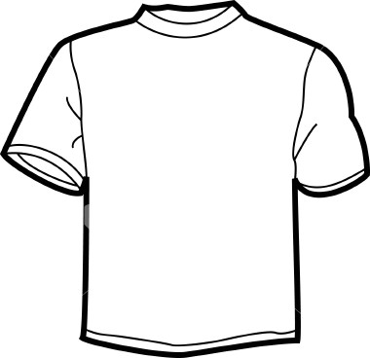
NWIL
ALLIES

- Fill out the entry form
- Draw your t-shirt design
- NWIL, Northwestern Illinois District or NWIL ALLIES must be on the shirt
- You can not use logos
(example Nike, Sport Teams, Food Chains, etc.)
- Clean neat lines are helpful
- Designs will be printed in black or white. You can use up to 3 additional colors.
- Put your design in the basket provided in the Art judging room.
- Designs will be judged before the end of the day

A graphic design artist will use the chosen design to create our district CL shirts.
Design may be altered.

