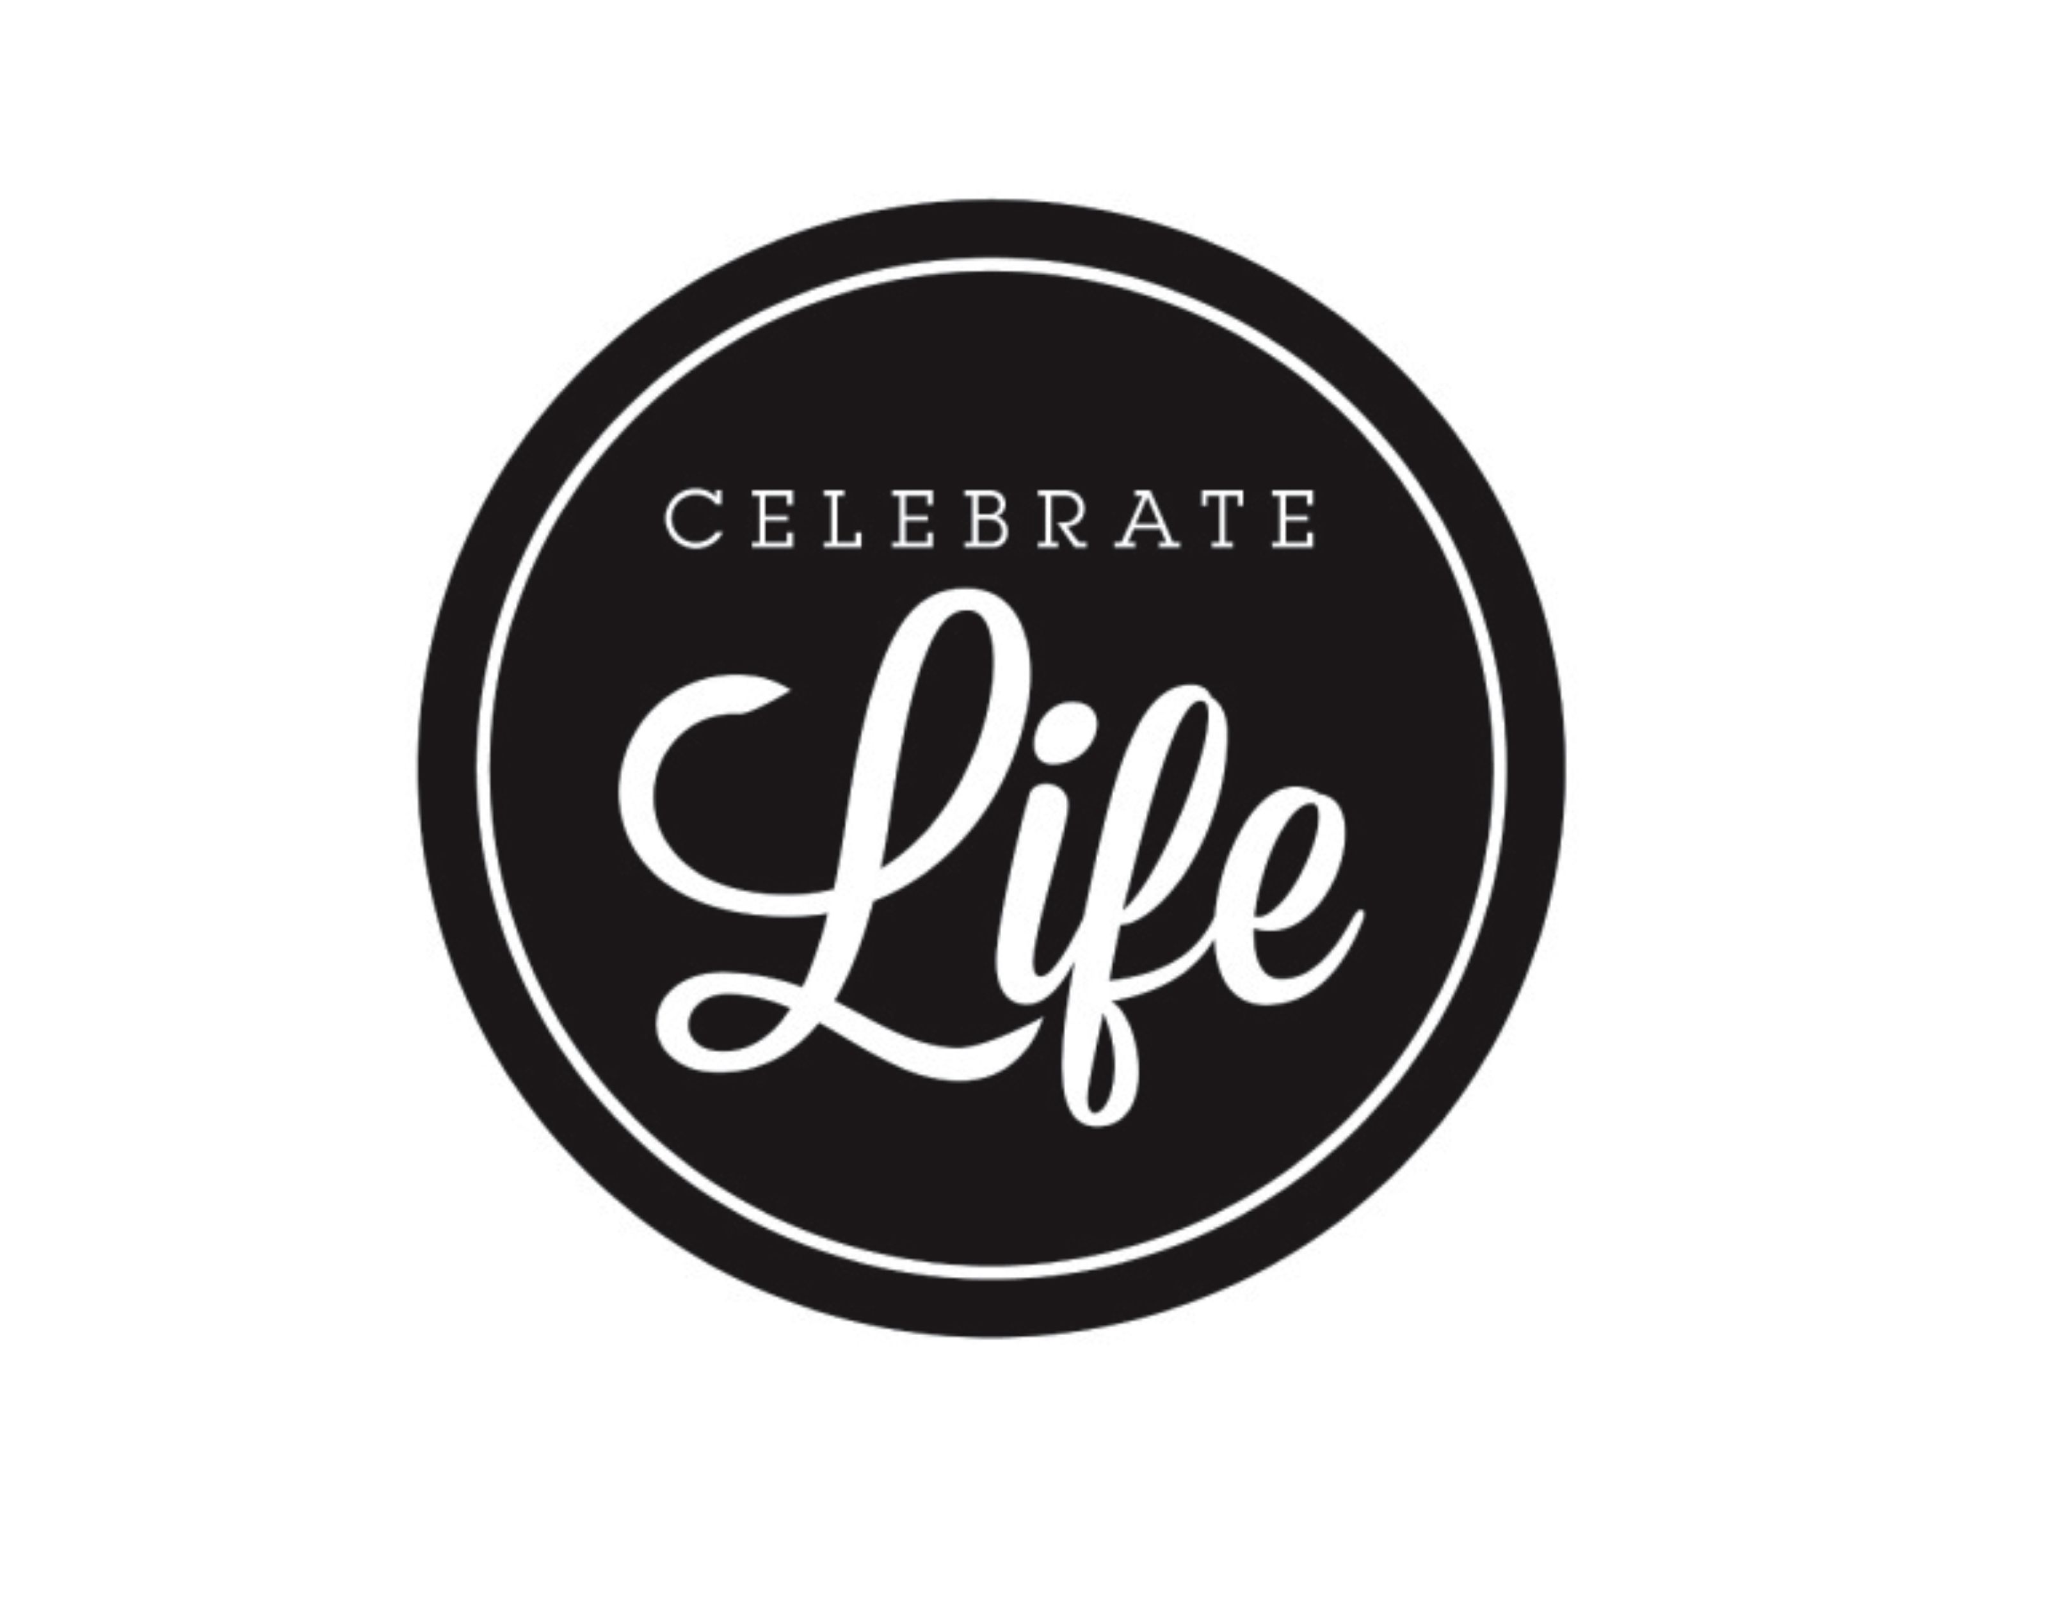
NWIL CL – FEBRUARY 26, 2022
OLIVET CL – MAY 12-14, 2022
PARTICIPANT INFORMATION
Celebrate Life is designed to create purpose, to further develop our students’ abilities and to encourage a solid foundation in Christ. Celebrate Life will also enable our district to come together as a community of Christ and will strengthen the relationship between our NWIL District and Olivet Nazarene University.
**CHANGES THIS YEAR – There will be no SCIENCE QUIZZING
CHESS - only one participant (no more early youth and senior youth)
You may choose to compete in a team sport or an individual sport. The team sports are as follows: men’s and women’s basketball, men’s and women’s volleyball, co-ed soccer and co-ed bowling.
The individual sports are: hotshots, free throws, table tennis, tennis, home run derby and the 5K run.
Another area that you may choose to participate in is the area of talent. The following are areas of talent that you may compete in:
Vocal music - solo, duet, trio, ensemble, choir, or rap.
Arts- painting, drawing, sculpture/crafts, still photography.
Chess
Instrumentals – keyboard solo, instrumental solo or ensemble, band.
Communications - drama, creative writing, mime, speech/reading, puppetry, Bible exposition
Video Production
Designing District T-Shirt for Field Celebrate Life

The last area that you may compete in is the NYI Bible Quizzing Program, which is run in the local churches from September through April each year.
The first opportunity to compete in any of these areas will be at the District Celebrate Life on February 26, 2022 The cost of this event is $25.00. The location will be at Pekin First Church of the Nazarene, 3514 Broadway, Pekin, IL. At this event, you will have a chance to try out for all of the sports teams or individual sports. You will also have the opportunity to compete in any of the above-mentioned talent areas.
Please note: There will be no competition events at the district level for those that are interested in tennis, home run derby, Dodge ball, Hot Shot, Free Throw or the 5K run. All persons interested in these events will automatically advance to Celebrate Life competition at Olivet in May of 2020. Please fill out a registration form so you can be added to the team. *There are limits of the number that can participate, first to register will get a spot.
District Bible quiz team will attend the competition for Celebrate Life that is held at Olivet Nazarene University in Bourbonnais, IL. NWIL District will compete against 10 other districts from four states. Celebrate Life is designed to encourage the development and abilities of the youth of our region for ministry in the name of Jesus.
So, if you have an interest in the sports listed above or an interest in any of the talent categories, I would encourage you to try out for Celebrate Life and take advantage of this wonderful opportunity to use the talents that God gave you for Him!
See your youth leader for information on registering for Celebrate Life.
Please go to nwilnaz.org for additional information

