Celebrate Life
NORTHWESTERN ILLINOIS DISTRICT
YOUTH PASTOR/LEADER INFO
Dear Pastor, Youth Pastor, NYI President, and Youth Worker:
**CHANGES THIS YEAR – There will be no SCIENCE QUIZZING
CHESS - only one participant (no more early youth and senior youth)
Below is the information that you will need to register your youth for our District Celebrate Life event to be held on Saturday February 26, 2022. The cost of the event is only $25.00, and that includes all the competition events on Saturday, along with lunch on Saturday. The deadline for the event registration is February 1, 2022. All registrations postmarked after February 1, 2022 will pay $50.00 per participant.
- T-shirt design forms can be printed, participants will bring design to CL, a basket will be provided in the Art room to put their design to be judged (read & print rules)
- All Students & Sponsors are to write their checks to their local church
- Youth leader will write ONE check to NWIL-NYI
- Please include the spreadsheet with all students and sponsors attending (print)
- Copy of insurance card for all participants
- Please do not staple registration forms & insurance copy together. Please use a paper clip. (We make copies of all forms. This process helps us with time management)
- Print registration forms 2-sided
Please make every effort to bring your youth to this exciting district event!! This year it will be held at Pekin First Church of the Nazarene, 3514 Broadway St. Pekin, IL 61554. Registration is 8:30am-9:30am on Saturday. We will meet in the Sanctuary at 9:30 a.m. for a time of worship. All competition events will begin following the service. There will be sports competition, talent, and art. While the competition is taking place, there will be an area with games and a place for the teens to just hang out. (There will be NO Bible Quizzing at this event).
Pizza and beverages will be delivered around 11:30 a.m. this is included in registration fees. The bowlers will meet at 11:45 a.m. so they can be at the bowling alley by 12:00 pm. The cost for bowling is $10.00 and that is an additional cost and must be pre-paid at registration. The $10.00 includes 3 games and shoe rental. You must bowl three games so that we can take your average to be considered for the district bowling team.
Home Run Derby, Tennis, Dodgeball and the 5K Run will once again be held at Olivet’s Celebrate Life in May, but we will not be competing at the District Celebrate Life for these events. If you have a student who is interested in attending Olivet’s Celebrate Life and would like to compete in one of these events, please indicate that on a district event registration form.
There will be a $5.00 charge for each sponsor, to cover lunch. Please add that to your youth group’s registrations and have each sponsor complete a Sponsor Registration Form.
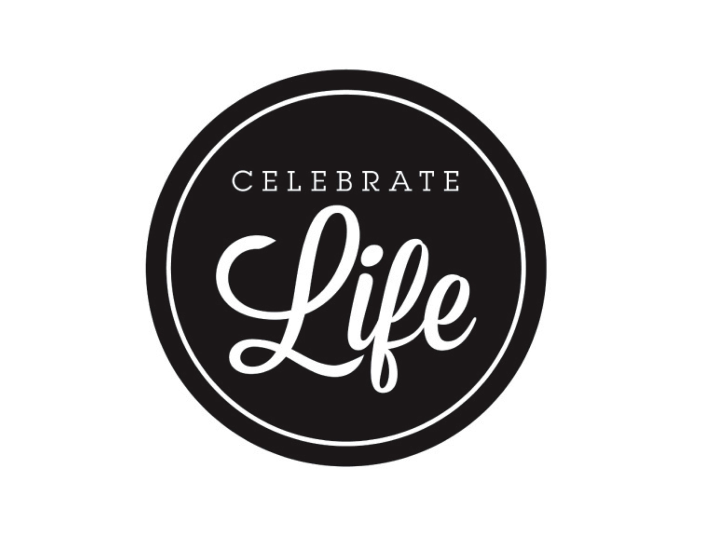
Please take the time to look over all the paperwork. Deadline: February 1, 2022. If you have any questions, please feel free to contact us.
We are looking forward to seeing each of you at the District Celebrate Life in February!!
Blessings,
Pam Smith OLIVET CELEBRATE LIFE
NWIL CL Director MAY 12-14, 2022
nwilpamsmith@gmail.com
309-208-7595

