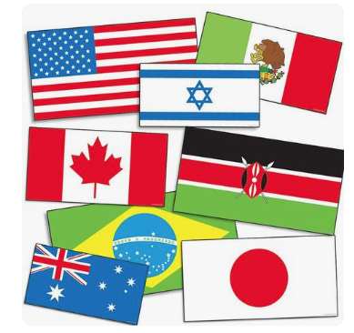
RENT CONVENTION FLAGS!
Your church can be the first to rent one or more of our convention flags!
(Unfortunately, stands and poles are NOT available for rent.)
NWIL NMI Treasurer Resource Secretary
3520 Broadway St. Rev. Ron Jansen
Pekin, IL 61554 18 Rosewood Lane
Pekin, IL 61554
Flag Rental Policy:
- Flags are $2.00 rental charge for each flag ordered. Give or mail checks to NWIL NMI Treasurer.
- To order: Call Resource Secretary @ 309-258-9224 or email Rev.ronjansen@yahoo.com
- If specific flags are desired, please specify when ordering. Allow at least two (2) weeks for receipt if flags are to be mailed. (Call or email Resources Secretary with any questions.)
- Make checks payable to: NWIL NMI Treasurer
- Postage to return flags to Resource Secretary will be the responsibility of each church.
FLAG INVENTORY AVAILABLE
 | American Samoa |  | Guatemala |  | Paraguay
 | Angola |  | Guinea Conakry* |  | Peru
 | Antigua & Barbuda* |  | Guyana |  | Philippines
 | Argentina |  | Haiti* |  | Portugal*
 | Australia* |  | Honduras* |  | Puerto Rico
 | Azores |  | Hong Kong (SAR) |  | Romania
 | Bahamas |  | Hungary |  | Russia*
 | Bangladesh |  | India* |  | Rwanda
 | Barbados |  | Italy* |  | Samoa
 | Belize |  | Ivory Coast* |  | Sao Tome & Principe
 | Bermuda |  | Jamaica* |  | Senegal
 | Bolivia |  | Japan |  | Solomon Islands
 | Botswana |  | Kenya* |  | South Africa*
 | Brazil |  | Korea, South |  | Spain
 | Bulgaria |  | Lesotho |  | St. Kitts And Nevis
 | Burkina Faso |  | Liberia |  | St. Lucia
 | Cambodia |  | Madagascar |  | St. Martin
 | Canada* |  | Malawi |  | St. Vincent
 | Cape Verde* |  | Mali* |  | Swaziland*
 | Chile |  | Martinique |  | Switzerland
 | Columbia* |  | Mexico* |  | Syria
 | Costa Rica |  | Moldova* |  | Taiwan
 | Creative Access |  | Mozambique |  | Tanzania
 | Cuba |  | Myanmar (Burma) |  | Thailand
 | Denmark |  | Namibia |  | Trinidad & Tabago*
 | Dominica |  | Nepal |  | Uganda
 | Dominican Republic |  | Netherlands |  | Ukraine
 | Ecuador* |  | New Zealand |  | United Kingdom*
 | El Salvador* |  | Nicaragua* |  | United States
 | France* |  | Niger* |  | Uruguay
 | French Guiana* |  | Nigeria |  | Venezuela*
 | Germany* |  | Norway* |  | Virgin Islands
 | Ghana |  | Pakistan |  | Zambia
 | Grenada |  | Palau |  | Zimbabwe

